**Consumer Financial Protection Bureau (CFPB)**

The Consumer Financial Protection Bureau (CFPB) is a regulatory agency charged with overseeing financial products and services that are offered to consumers. The CFPB is divided into several units—Operations; Consumer Education & External Affairs; Legal; Supervision, Enforcement, and Fair Lending, and Research, Monitoring, and Regulations.

These units work together to protect and educate consumers about the various types of financial products and services that are available

The Consumer Financial Protection Bureau ensures that federal law involving financial law is enforced and implemented and that the markets for products and services for consumers are "fair, transparent, and competitive."

BUREAU FUND FISCAL YEAR TRANSFERS REQUESTED COMPARED TO THE FUNDING CAP, OBLIGATIONS AND UNOBLIGATED BALANCE ($ MILLIONS)

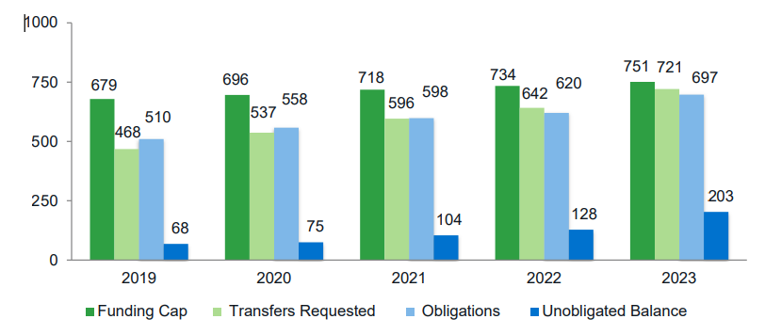

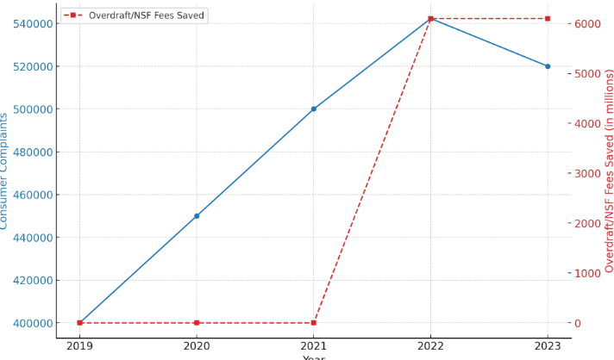

**Anti-Money Laundering Regulations US**

1. Bank Secrecy Act (BSA) (1970): Also known as the Currency and Foreign Transactions Reporting Act, the BSA requires financial institutions to keep records and file reports that are useful for detecting and preventing money laundering.
2. USA PATRIOT Act (2001): Enacted in response to the September 11 attacks, the USA PATRIOT Act significantly expanded AML requirements.
3. Financial Crimes Enforcement Network (FinCEN): A bureau of the U.S. Department of the Treasury, FinCEN oversees and enforces AML regulations. FinCEN collects and analyses information about financial transactions to combat money laundering, terrorist financing, and other financial crimes.
4. Office of Foreign Assets Control (OFAC): Also, part of the Treasury Department, OFAC administers and enforces economic and trade sanctions against targeted foreign countries and regimes, terrorists, international narcotics traffickers, those engaged in activities related to the proliferation of weapons of mass destruction, and other threats to U.S. national security, foreign policy, or economy
5. Customer Due Diligence (CDD) Rule: Effective from May 2018, this rule requires financial institutions to identify and verify the identities of beneficial owners of legal entity customers. It ensures that financial institutions understand who their customers are and the nature and purpose of the relationships.
6. Anti-Money Laundering Act of 2020 (AMLA): Part of the National Défense Authorization Act for Fiscal Year 2021, the AMLA includes significant reforms to the AML/CFT (Countering the Financing of Terrorism) framework.

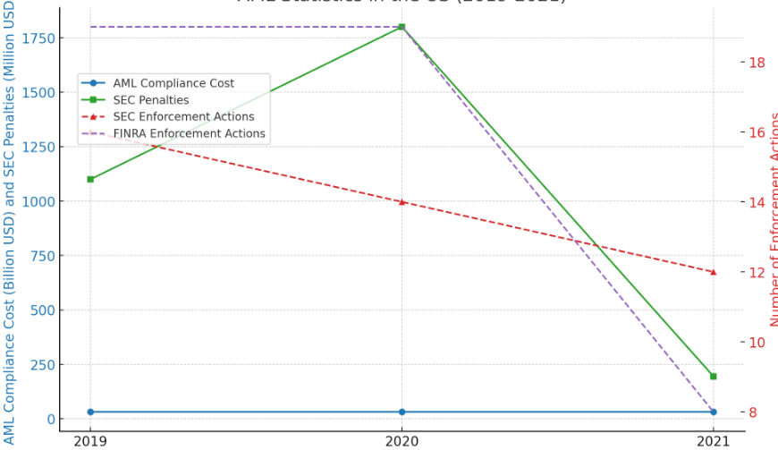

**Know Your Customer Regulations**

"Know Your Customer" (KYC) regulations are a critical part of anti-money laundering (AML) measures and are designed to ensure that financial institutions verify the identity of their clients and understand the nature of their business activities. These regulations help to prevent identity theft, financial fraud, money laundering, and terrorist financing.

### Legal Framework and Guidelines:

1. **Bank Secrecy Act (BSA)**:
   * The foundational law for AML and KYC in the United States, requiring financial institutions to assist U.S. government agencies in detecting and preventing money laundering.
2. **USA PATRIOT Act**:
   * Expanded KYC requirements, mandating CIPs for all financial institutions and enhancing CDD and EDD requirements.
3. **Financial Crimes Enforcement Network (FinCEN)**:
   * The U.S. Department of the Treasury bureau responsible for enforcing KYC regulations and overseeing AML compliance.
4. **Office of Foreign Assets Control (OFAC)**:
   * Requires financial institutions to ensure they do not conduct business with individuals or entities on sanctions lists.

|  |  |  |  |  |  |  |  |  |  |
| --- | --- | --- | --- | --- | --- | --- | --- | --- | --- |
| **Year** | **KYC Compliance Cost** |  | **Total Fines** |  | **Cost Per KYC** |  | **Number of KYC Tasks** | |  |
| **(Million USD)** |  | **(billion USD)** |  | **Review (USD)** |  | **(Thousands)** |  | |
| 2019 | 60 | | 2 | | 2200 | | 1000 | | |
| 2020 | 69 | | 2.3 | | 2500 | | 900 | | |
| 2021 | 79.35 | | 2.6 | | 2900 | | 850 | | |
| 2022 | 92.84 | | 2.2 | | 3400 | | 730 | | |
| 2023 | 108.77 | | 2.5 | | 4000 | | 627 | | |

